**CONCLUSION:**

Finally, we can say that using machine learning, data analysis, and prediction we can hopefully predict a little good prediction about future trade. This is still not fully exact in giving exact information but it’s a like good step in front of change in trading world. This require more study and more analysis on various aspects.

But, here we can compare the stock prices of various firms with spy this will give us little idea that where can we invest and get good feedback.

Here is some screenshot of our work stock comparisons.

* **This is our front of stock market trading**

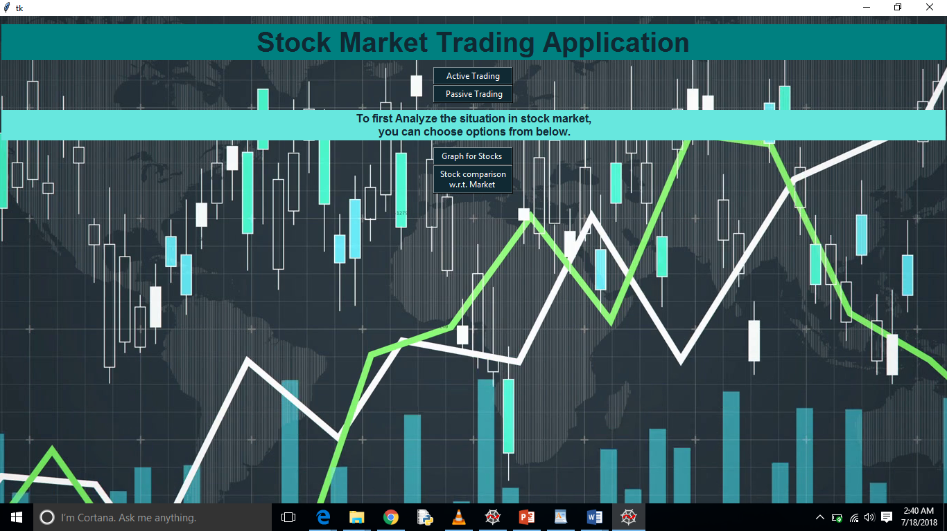

* **Here we can see apple stock for one month from 22-04-2018 to 20-05-2018**

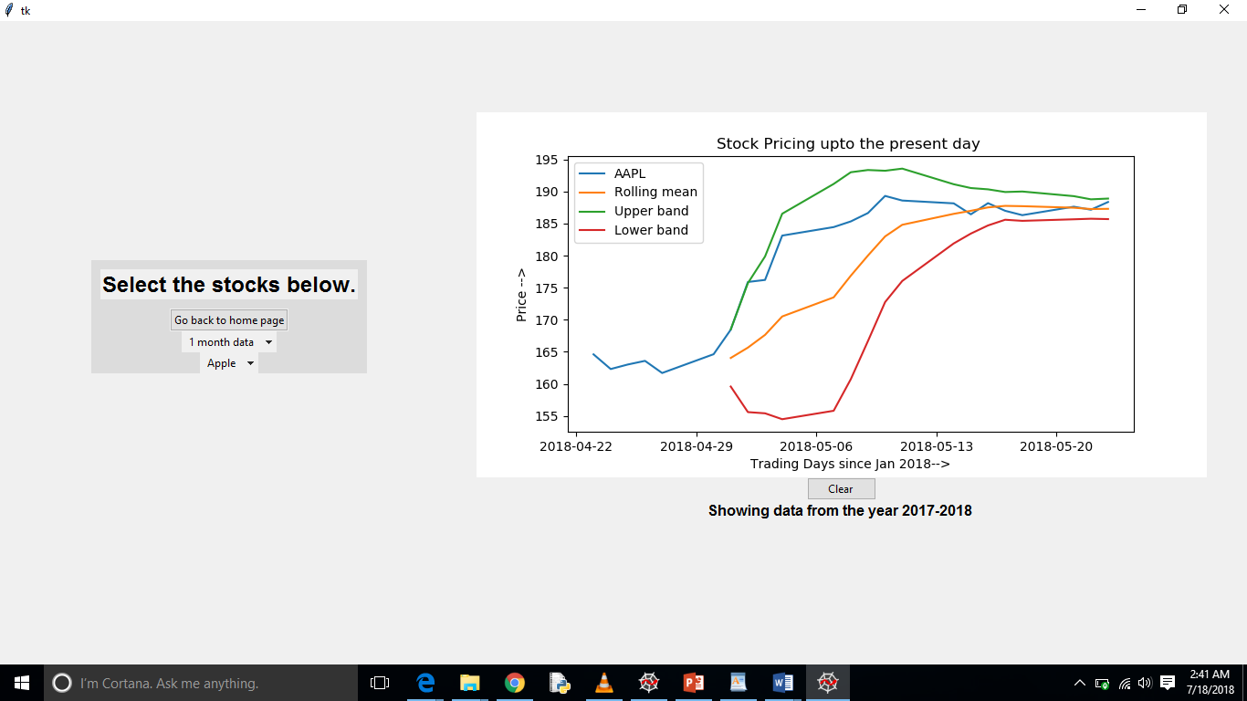

* **Here we are comparising the SPY with IBM in stock pricing**

